Tuesday 28th June 2022
To the Rotary Club,
I’m a pupil from Benfieldside Primary School and I’m thankful for all the things you gave to us! The trip to Beamish Museum, the hats, the ice-cream and everything else!
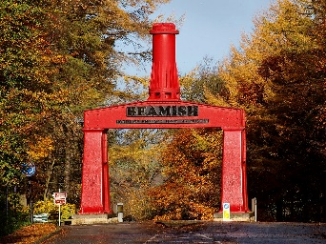
It was really fun at Beamish! I loved how there was people who told us about the olden days in the cottages and shops! By the way, the ice-cream was awesome; it helped with the unbearable heat!!
My favourite part of the trip last Friday was the Victorian school. It tied into our old topic too- the Victorians! We were told about life in a Victorian school and the punishments! (the worst part!) And also, we got to play with the hoop and sticks- I was the one pro at it and had to teach everyone else!!
It was just a generally nice day to go to Beamish!
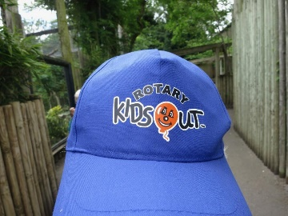
Once again, thank you for the trip and all. It was REALLY, REALLY fun!
PS: I still have the hat, I love it!

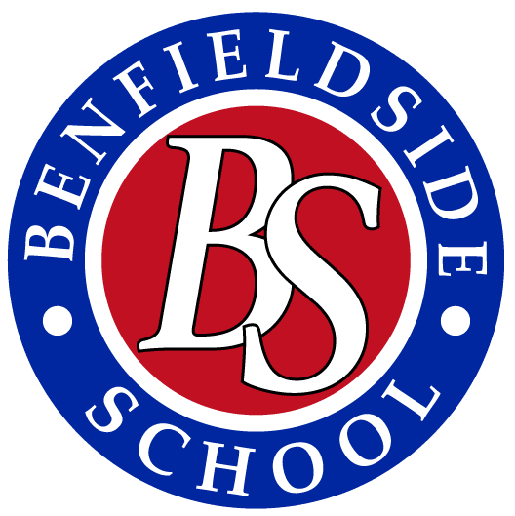
Monday 27th June

Dear the Rotary Club,
We are pupils at Benfieldside Primary school, we really want to say a huge thank you for paying for our trip and for the ice cream- it really did cool us down. The hats protected us from the hot sun. Thanks for the bus too.
We had so much fun at Beamish Museum. Our favourite part was the school and the cottages. It actually felt like we were in 1913. We saw the trams, some shops and the mine. All the workers were dressed like the 19132’s have you all ever been to Beamish museum for a trip? This was our first time at Beamish Museum.
On are way back to the bus, we saw loads of animals. Horses, fowls ,sheep and lambs-it was really exhausting at the end off all the walking. We want to say a huge, huge thank you.

Thank you very much.

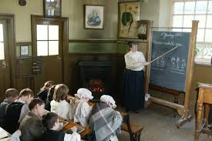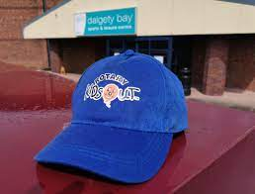

Monday 27th June 2022

To the Rotary club,
I’m a pupil at Benfieldside Primary school, I just want to say thank you so much for the wonderful trip!
It was truly amazing. I’m really thankful for everything even the ice cream, it
It did help with the forever lasting heat. Thank you for the bus and the trip I don’t think we could’ve all fit in our teachers car to get there.
The trip was astonishing, very good. Personally, I think when we got to the Victorian school and listened to this man that told us fun facts, rules and lessons that would happen in a normal school day was the best bit.
We enjoyed playing with the hoop and the stick. You had it roll the hoop and use the stick to make sure the hoop doesn’t fall. Or where we got to go and sit in the Victorian school.
It was very nice to explore and walk around all these houses and talk to the people to the people dressed and acted like Victorians. My favourite thing was the school.
Did you know that our topic last year was Victorians? So that tied up very nice with the trip.

Thank you for this amazing trip and sorting it out and making it not cost a penny for us.
Benfieldside primary school

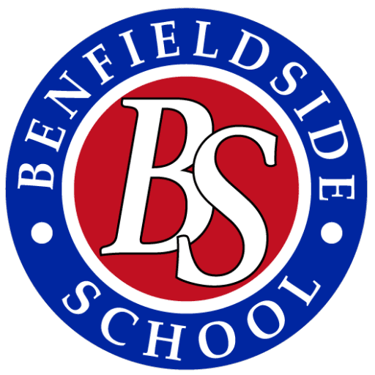

Monday 24th June

DEAR the Rotary Club,
Thanks For booking for us to go Beamish Museum. Thanks to Norman for being there when we got off the bus. Thank you for the ice-cream, it was really nice and cooled us down. It was really cool going into the old houses and school. Thank you for the caps, especially because they were blue and they kept the sun from getting in our faces. We also saw a chicken lay an egg and some roosters. We couldn’t do the metal hoop and stick. The buses were really nice and comfortable although it was very hot. It was really nice watching the trams and how they drove them. Our favourite things were the meatal hoop and stick the old fashioned houses. Our last topic was Victorian times so it was good to see what we had been learning about in history in person. Yet again, thank you. We hope to see you soon or hear from you soon,
From
Pupils at Benfieldside Primary School

Monday 27thJune

Dear the Rotary Club,
We are pupils at Benfieldside Primary school. Thank you for the trip to Beamish on Friday 24th June and the bus, hats and ice cream thank you for doing this for us.
Our favourite part was the school and learning about what happened in the Victorian schools. We enjoyed looking at the old things in the houses. In the old houses, there were old paintings and wooden toys on little shelfs.
We saw loads of old trams and different types of toys and houses. We would see people going on the trams and workers dressed in clothes they would be dressed in Victorian times. We went in a couple of different cottages. The teachers told us what would happen if you were naughty. We played with the hoops and played hopscotch at playtime.
How old were all the things in Beamish?
There were loads of things from Victorian times and old paintings. Thanks to Norman for meeting us off the bus.

Thank you,
Hope to hear from you soon
Benfieldside Primary school. 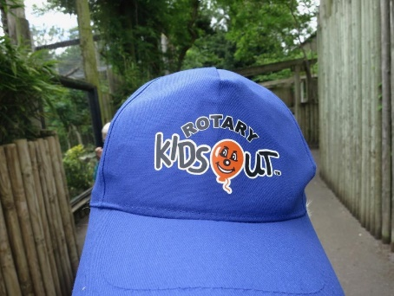

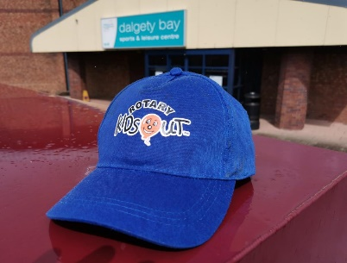
Monday 27th June 2022

To the Rotary Club,
We are pupils from Benfieldside Primary school, we are writing this letter to say thank you for paying for our trip to Beamish museum on Friday 24th June. Also, thank you for paying for the bus to go to Beamish museum, for the hats and for the ice cream-it was very hot that day so we definitely needed it.
We really enjoyed it and hope to go again soon-it was amazing. We went into the cottages and the blankets and beds were very detailed, that’s how they were back then. Making the blankets would take twice more work than it does today. We played with the hoop and stick after we went into the Victorian school. The toys in the playground reminded us of our topic of Victorian toys.
Thank you again for everything, hope we see you again soon.
From
Benfieldside Primary School Pupils

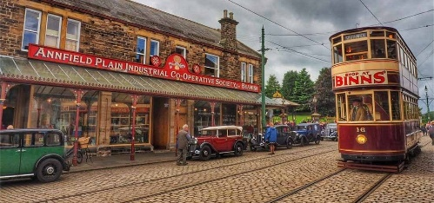
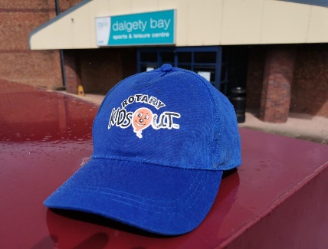

Monday 24thJune

Dear the Rotary club,
Thank you for the hats, ice cream, bus and the trip to Beamish Museum on Friday 24th June.
We really liked seeing the chickens and the lambs and going to the school.
We really enjoyed learning about Victorian times in school. Particularly, the part about the punishments-you get hit by the cane.
The cottages had great detail on the beds, mirrors and the rooms.
It was nice to have a look around to see what it would look like back then

Thank you again for everything. Hope to hear from you soon.

From
Benfieldside Primary School

Monday 27th June 2022
To the Rotary club,
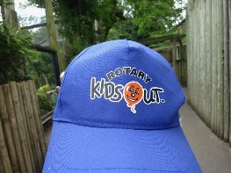
We are two from Benfieldside Primary school. We really appreciated the ice cream and the trip on Friday 24th June. The hats were very helpful because it was a very hot day, so we are very grateful. We really liked the ice cream it was very good we really loved the taste.
Moreover, we really loved how the museum was related to the Victorians, back in the olden days. We also liked it when we played hopscotch and the hoop and stick one.
We saw the chickens and the chicks, sheep and the white horses and the cottages next to the vegetables. Thank you for saving us from a day from school.

Thank you, I hope to hear from you soon,

